Personal Study Plan
Define the objective or focus of the essay:
”The concept of the camera and that of photography are so often interwined that it is perhaps surprising just how pedestrian a role the machine itself played in the invention of the art.” LARRY J SCHAAF

The objective/focus of my essay is to explore the work of photographers that make photographs without a camera. I will investigate the cameraless photography techniques used and discuss how you don’t need a camera to take a photograph.
The relationship between the practical work and the focus of the study:
For my practical work, I plan on exploring various objects using the photogram technique. I plan on making photograms in the darkroom with different objects. I will be looking at Man Ray’s work about his rayographs which he made by putting objects/materials and at times parts of his own/model’s body on the sheet made of photosensitized paper which he then let it get exposed to light which created negative images. I will look at opaque, transparent and translucent objects and how the objects block light from the photographic paper. I will also experiment with photographic chemistry and the effect these have on the image, using brushes and sprays. I will also look at the work of Laszlo Moholy-Nagy, Man Ray.
Sources to be used:
Books (at least THREE): | Websites: | Other sources:
Susan Derges,liquid form  SHADOW CATCHERS CAMERA-LESS PHOTOGRAPHY Martin Barnes  LIGHT,PAPER,PROCESS REINVENTING PHOTOGRAPHY VIRGINIA HECKERT  Alchemy published by Purdy Hicks  Experimental vision The Evolution of the Photogram since 1919 Essays by Floris M.Neusüss Thomas Barrow Charles Hagen Roberts Rinehart Publishers in association with the Denver Art Museum. | https://www.hccart.co.uk/l6-photography

List the pieces of work that you will analyse in the study. Identify reasons for choosing these particular pieces and points that may be highlighted in the analysis. Mark the primary source/s with *
Name of piece: | Reasons for choice/Points to be raised:
IMAGE 1- LASLO MAHOLY-NAGY  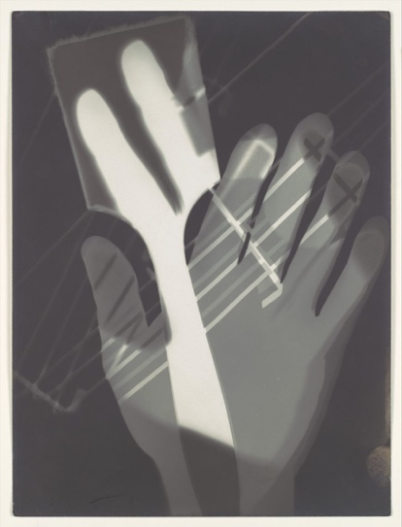 IMAGE 2 SUSAN DERGE – S ‘RIVER TAW’  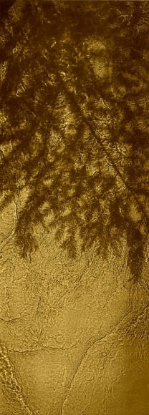  IMAGE 3- PIERRE CORDIER  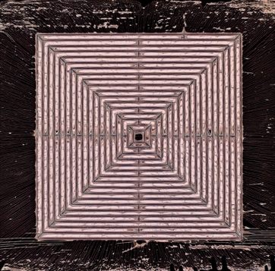 | This is done in a darkroom and has shadows put on top one another. Moholy-Nagy thought the photogram was modern.  Visual metaphors that explores self /nature. Capturing visible/invisible scientific and natural processes.  Chemigram is a combination of physics of painting such as varnish/wax/oil and chemistry of photography such as photosensitive emulsion/developer/mixer.
Visit/s made/to be made:
Possible conclusion/s to the study:
To make photograms in the darkroom using different objects. To have more knowledge about the photographers that I will be researching about.

